|  |  |
| --- | --- |
|  |  |

|  |
| --- |
| **Activity 6.2.6 Transistors** |

Introduction

A transistor can be used to boost sounds. The hearing aid became the first commercial device to utilize the transistor after its invention in the 1940s. In the early 1950s, AT&T had patents on many improvements to transistors. They offered free transistor licenses to hearing aid companies in honor of Alexander Graham Bell. Bell, the inventor of the telephone, had devoted his life to helping those who were hard of hearing. In a very short amount of time, hearing aids with transistor technology were available. The competition among those companies created rapid improvement and lower prices.

Equipment

* Transistors presentation
* Schematic Symbols Chart
* Engineering notebook
* Highlighter
* Snap circuit LED
* 1 KΩ Resistor
* 5.1KΩ Resistor
* NPN Transistor
* 9V battery with snap
* Photoresistor
* Flashlight (depending on the sensitivity of the phototransistor)
* Snap Circuits® components
* Board, voltage source, and power supply
* 1KΩ Resistor
* 5.1 KΩ Resistor
* 10 KΩ Resitor
* NPN Transistor
* 2 LEDs
* Pushbutton switch
* Various sizes of snap wires

Procedure

Use The Transistor Nobel Prize PDF to answer the introductory questions about transistors below. Later in this activity you will use a transistor as a switching device to cause a light to come on when light surrounding the device decreases, a night light circuit.

**6.2.6.A TheTransistorNobelPrize.pdf**

Read all 38 pages answering the questions, and then try building a transistor on <http://www.nobelprize.org/educational/physics/transistor/function/thegame.html>**.**

1. What do people sometimes call the transistor?

The nerve cell of the information technology.

1. What was the purpose of a “crystal” and what was it made out of (general name.)

A crystal removed noise from the radio signal and was made out of lead sulfide, fool’s gold, and zinc oxide.

1. What is “Rectification”?

When current is only allowed to flow in one direction.

1. What are the general properties of a semiconductor?

They have a conductivity between a conductor and an insulator.

1. What are the two most used semiconductor materials?

Silicon and Germanium

1. Which one is used most often, and why?

Silicon because it is the second most abundant element in Earth’s crust.

1. What are the two types of dopants?

n-type and p-type

1. Briefly describe reversed bias.

The polarity of the battery sends a current to a P-N junction and if the junction is backwards so that the light doesn’t turn on, the holes are being attracted towards opposite sides, not allowing electrons to flow.

1. Briefly describe forward bias.

The polarity of the battery sends a current that will repel the holes and provide a space for electrons to flow through.

1. Name the three scientists who created the first transistor.

William Shockley, John Bardeen, and Walter Brattain

1. Where did the word “transistor” come from?

It was originally called a transfer resistor, which became combined into transistor.

1. What are the names of the three electrodes in a transistor?

Base-electrode, emmiter-electrode, collector-electrode

1. Which electrode is represented with an arrow in a schematic?

The Emmiter electrode

1. Why do we not use point-contact transistors?

Because they are hard to mass produce.

1. What does MOSFET stand for?

Metal-Oxide Semiconductor Field-Effect Transistor

1. What are the electrodes called in a MOSFET transistor?

Source, Drain, and Gate

1. What every-day fixture does a transistor resemble?

Water tap

1. What are the two main uses of a transistor?

Amplification and Switching

1. What are the two major differences between a mechanical switch and a transistor?

A transistor has no moving parts and switch between on and off much faster.

1. What is an integrated circuit?

A single piece of semiconductor material and contains transistors and other electronical components.

1. Name the two scientists who created the first integrated circuit.

Jack Kilby and Robert Noyce

As you are learning, Transistors are _Semiconductor_ devices with three small leads (legs). A very small current or voltage at one lead (leg) can control a much larger current flowing through the other two leads. This means transistors can be used as _Amplifiers_ and _Switches_.

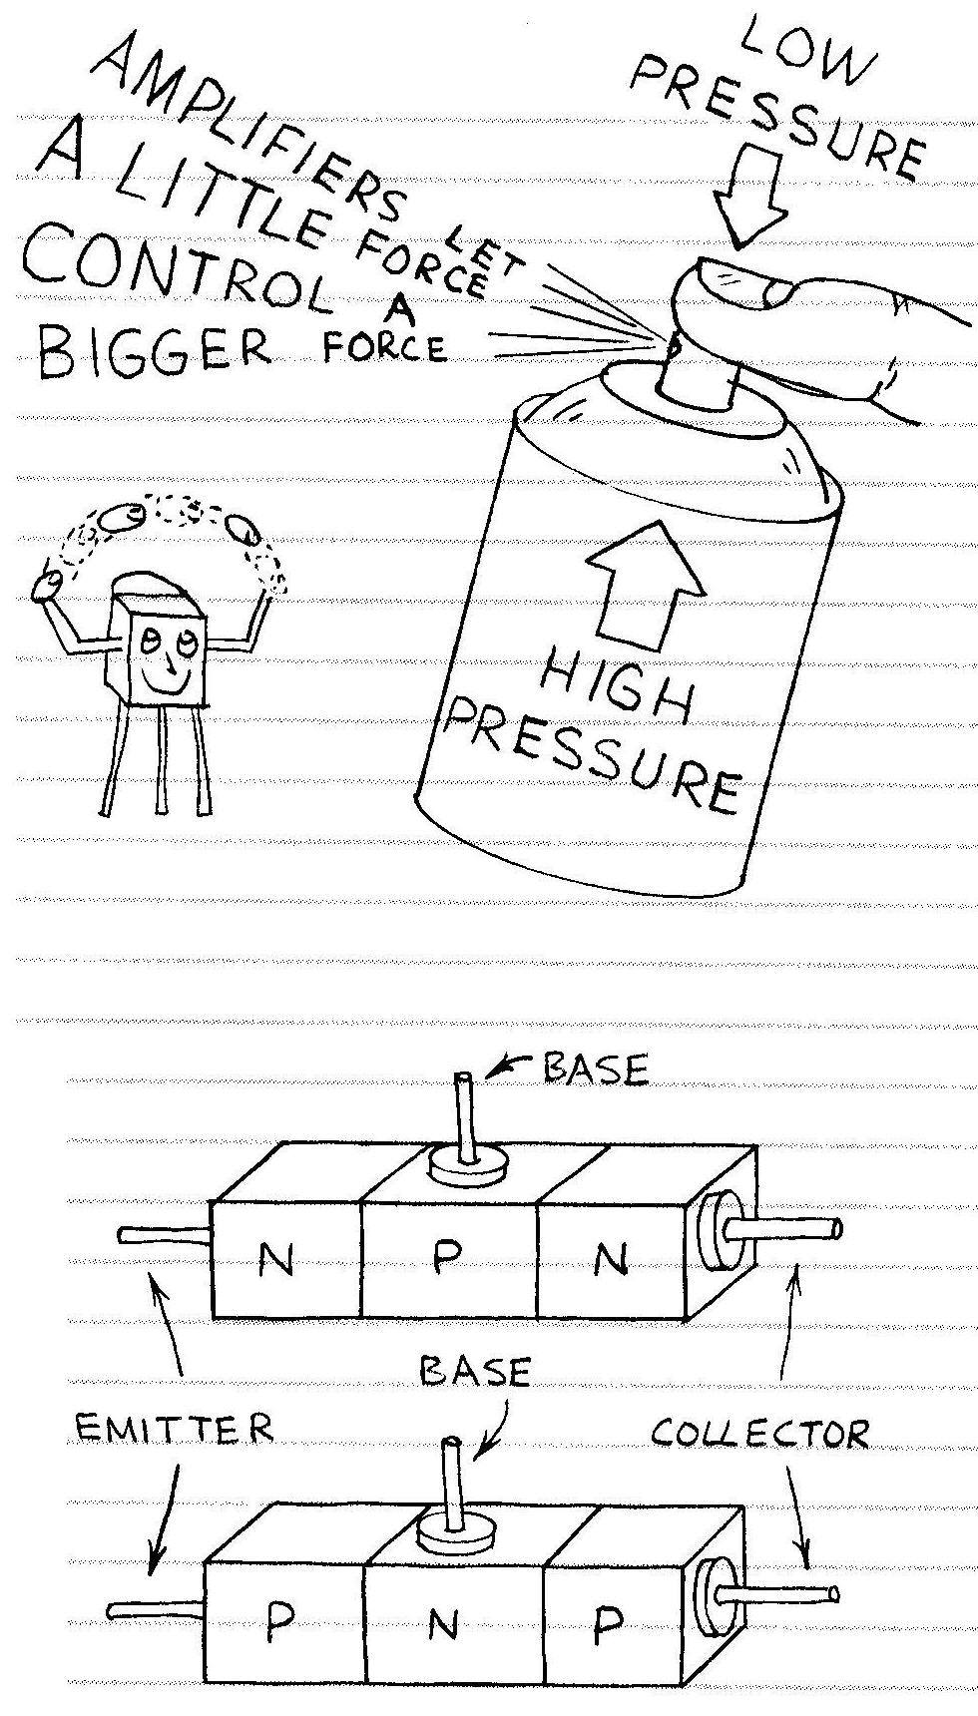

Add a second junction to a PN junction diode and you get a 3-layer silicon sandwich. The sandwich can be either _npn_ or _pnp_. Either way, the middle layer acts like a gate that controls the current moving through the three layers.

The three layers of a transistor are the _Collector_, _Base_ and the _Emitter_. The base is very thin and has fewer doping atoms than the emitter and collector. Therefore, a very small emitter-base current will cause a much larger emitter-collector current to flow.

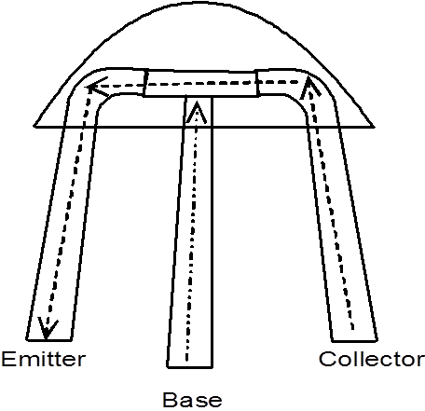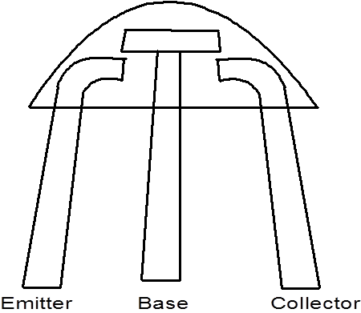

A small current to the base enables the transistor to conduct current from the collector to the emitter, and allows a larger current to flow through the transistor. Components connected to the collector can use this larger current.

When there is no current to the base, no current can flow between the collector and the emitter and the transistor is off.

Draw the schematic diagram, and then build the circuit demonstrating the “Transistor as a Switch” as shown in the **Transistors** presentation.

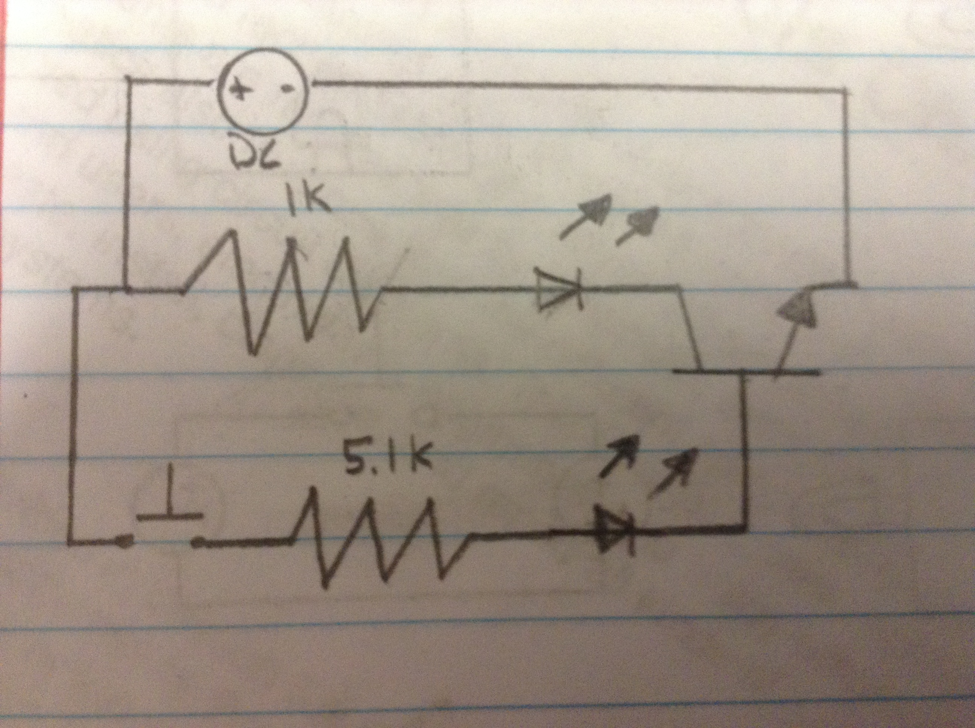

Instructor Verification of Transistor Switch Circuit ________________

Follow along with the Night Light Circuit presentation. Draw of your schematic of the circuit below, then using the Snap Circuits®, build the Night Light.

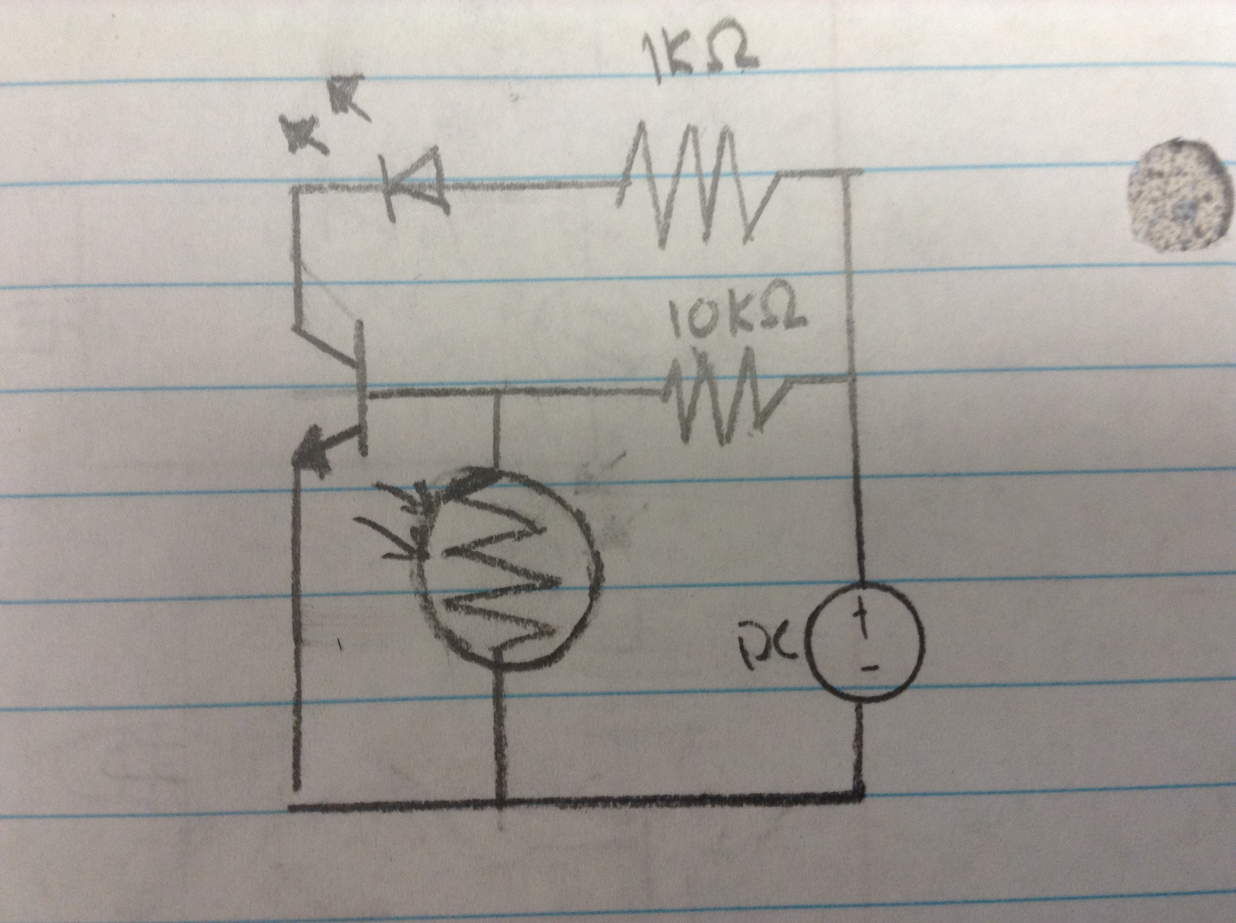

Instructor Verification of Snap Circuits® Night Light ____________________

Using the method demonstrated by your instructor, solder your Night Light circuit.

Instructor Verification of soldered Night Light circuit ______________________

Conclusion

1. Consider street lights that come on automatically. Why is it important that a low amount of current is sent to the base of a transistor, but that the collector and emitter are able to handle a large amount of current?

A low amount into the base is so that the street lights don’t overload, and the emitter and collector can handle a large amount because there is a lot of current flowing through to turn on all the lights.

1. What are some advantages of making electronic components like transistors increasingly smaller?

So that we can reduce the size of more complex devices and then continue to add on to them by making new technologies smaller.

1. Fill in the information on the next page. Use a highlighter to indicate current flow.

**When there’s Light:**

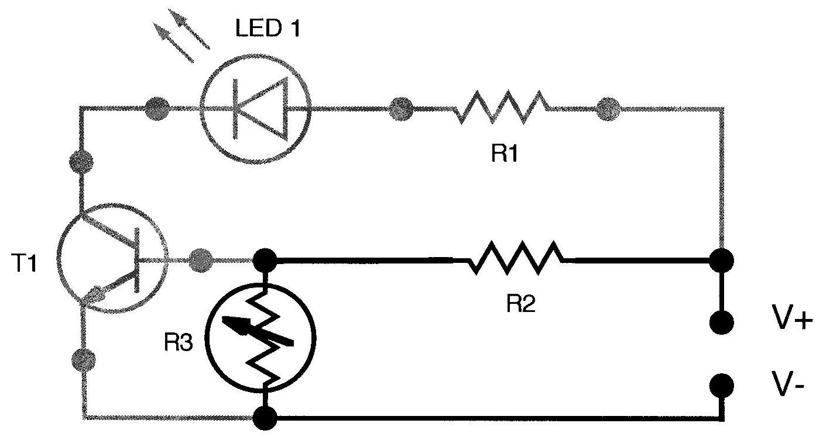

In light, the photocell’s resistance is _low_ (high or low) and there is current flow through R2 and the photocell. The transistor acts as a/an _Insulator_ (insulator or conductor) and the path containing R1, LED1, and the transistor is _closed_ (open or closed) or _off_ (off or on.)

**When it’s dark:**

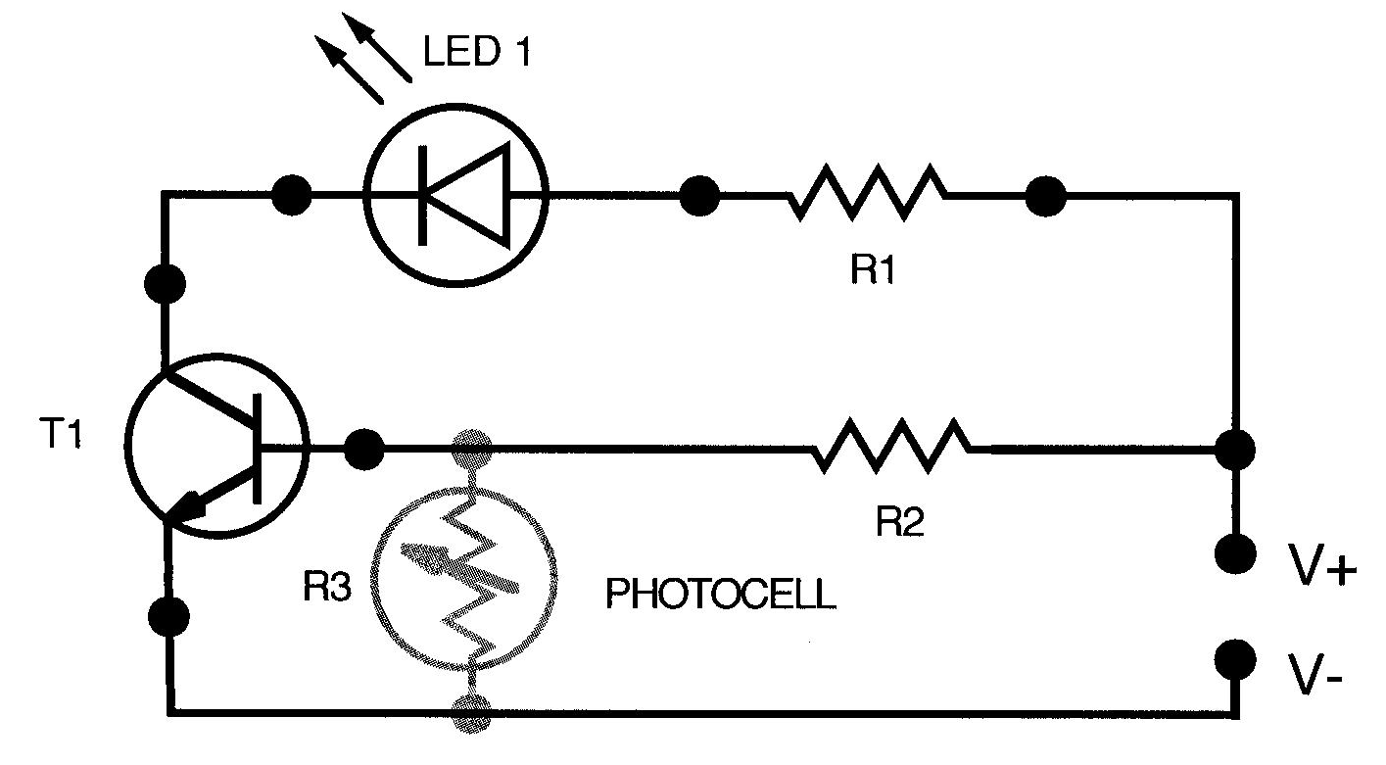

In darkness, the photocell’s resistance goes _high_, (high or low) so the circuit path changes. Now the path of less resistance is to the transistor base rather than through the photocell. When the base of a transistor is energized, the transistor acts as a _Conductor_ (insulator or conductor.) The path containing R1, LED 1 and the transistor is _open_ (open or closed) or _on_ (off or on) and the LED lights.

**Be sure to highlight the current path in each of the schematics.**